Labs Data & AI Innovation Day

Lab 4: Build a web app with Azure open AI connected to Cosmos dB MongoDB Vcore

This document describes how to create and deploy an azure Web application using the data populates the Azure Cosmos DB for MongoDB collection.

# Pre-requisites

Ensure that you have the following software installed on your system before proceeding with the lab:

* Azure cosmos dB mongo Vcore
* Optional an azure Speech service
* Azure OpenAI account registered in the Azure subscription used for this lab with deployment of azure open AI model. (Lab 3)
* Data on your Azure cosmos DB mongo Vcore environment (Lab3)

# Configure the Chat environment in azure open AI.

Follow these steps to Create a chat conversation who will interact with your data in Azure Cosmos dB MongoDB Vcore

* Login to the Azure Portal
* Connect to the Azure OpenAI account.
* Click on Go to Azure OpenAI Studio, who will launch Azure Open AI studio A
* A screenshot of a computer

  Description automatically generated
* In the left menu, select “chat.”
* In assistant Setup select “add your own Data” and click on “add a data source “
* Click on select a data source and select Azure cosmos dB MongoDB Vcore
* Add your information’s (subscription, Database account name …) like below.
* A screenshot of a computer

  Description automatically generated
* Click next.
* Select the different information (database, collection, index …)
* A screenshot of a computer

  Description automatically generated Click on next.
* In the content data add the following field for product: categoryId,categoryName,sku,name,description,price,tags.”
* Select the vector field.
* A screenshot of a computer

  Description automatically generated
* Click on next.
* Click on save on close.
* Go to the chat session Tab and ask a question.
  + Aks the following questions
    - “Do you sell mountain bike; do you have some details information on.”
    - The prompt should respond with some references.

# Add voice recognition in the chat.

Run these if you want to add voice recognition in your chat:

* In the chat session tab click on Playground setting
* Add your information on speech resources, language, and enable speech to text. Like below and click on save

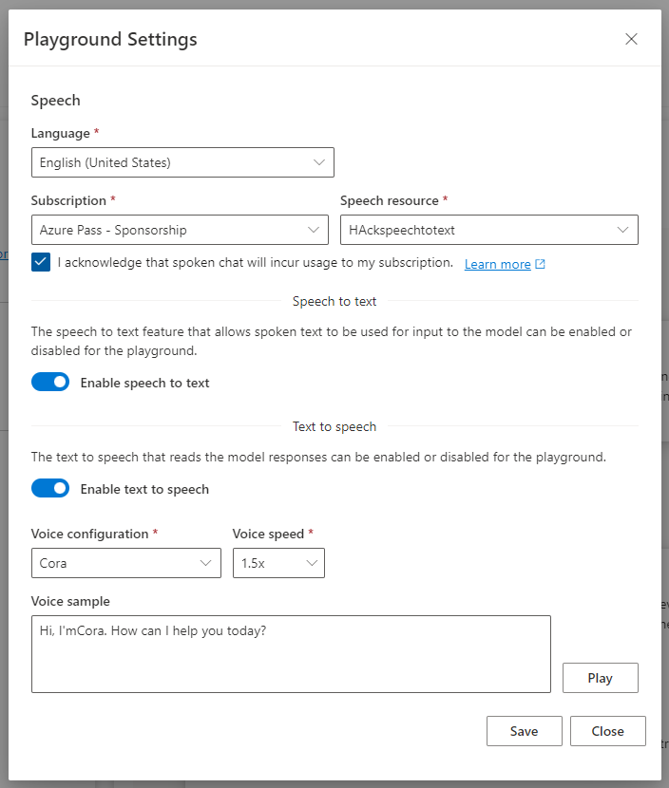

* In the chat you can test the speech to text and text to speak integration
* Click on the micro as shown below and ask the same question as before.
* 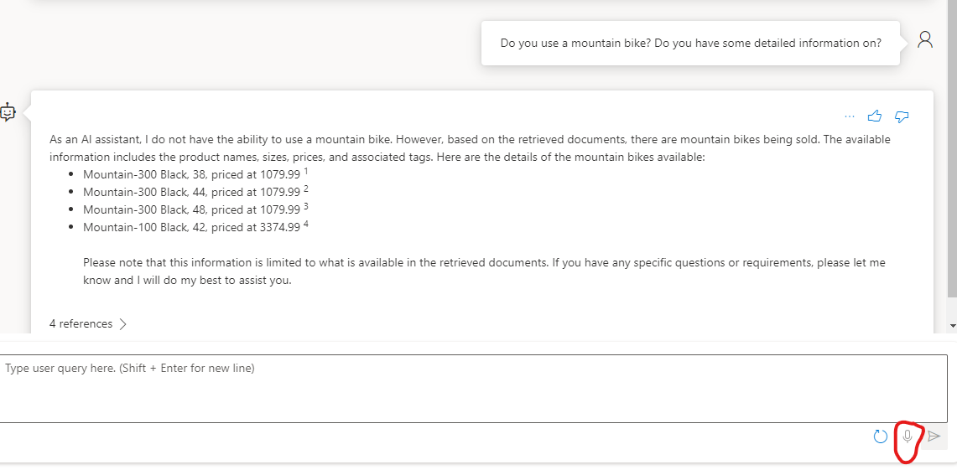

# Deploying an azure web application

In this section, you will deploy a chat web application using the configuration you have done before.

* Click on the chat playground on deploy to
* A screenshot of a computer

  Description automatically generated
* Select A new web app.
* Enter the Name of the web app, select the subscription the resource group, select a location, and select a pricing plan, select enable chat history in the web app and all the field like present below and click on deploy:
* A screenshot of a computer

  Description automatically generated
* The deployment is done, wait 10 minutes and go to the azure portal.

The application uses the GitHub template <https://github.com/microsoft/sample-app-aoai-chatGPT> , you can customize and change

* In the azure portal you will have a
  + An service plan : [asp-demoteam01](https://portal.azure.com/#@hackcosmosdbgmail.onmicrosoft.com/resource/subscriptions/d3ca5c12-8491-41aa-a3fe-d0b6b88aa64b/resourceGroups/hackopenaicosmosdb/providers/Microsoft.Web/serverfarms/asp-demoteam01)
  + An Azure Cosmos DB account [db-demoteam01](https://portal.azure.com/#@hackcosmosdbgmail.onmicrosoft.com/resource/subscriptions/d3ca5c12-8491-41aa-a3fe-d0b6b88aa64b/resourceGroups/hackopenAIcosmosdb/providers/Microsoft.DocumentDB/databaseAccounts/db-demoteam01) who will store in a collection name “conversations”
  + An App Service demoteam01
* Click on the app service and click on the Default domain URI. A new tab will be opening to your web app.
* Just click on Consent on behalf of your organization and accept as below.

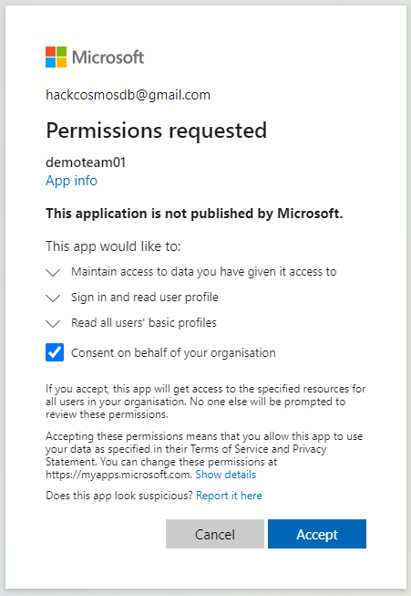

Add your question and a response is generated.

Go back to the azure portal, go the Azure cosmos dB account associated with the web application, click on the data explorer and in My data, go to the collection conversation and expand to see the item, some item should be registered.